Can I send iMessage using my eSIM?

Yes, you can send iMessage using your eSIM. Please remember that you may need to reset iMessage after installing your eSIM. Please follow these steps:

1. Go to Settings on your device

2. Go to Messages
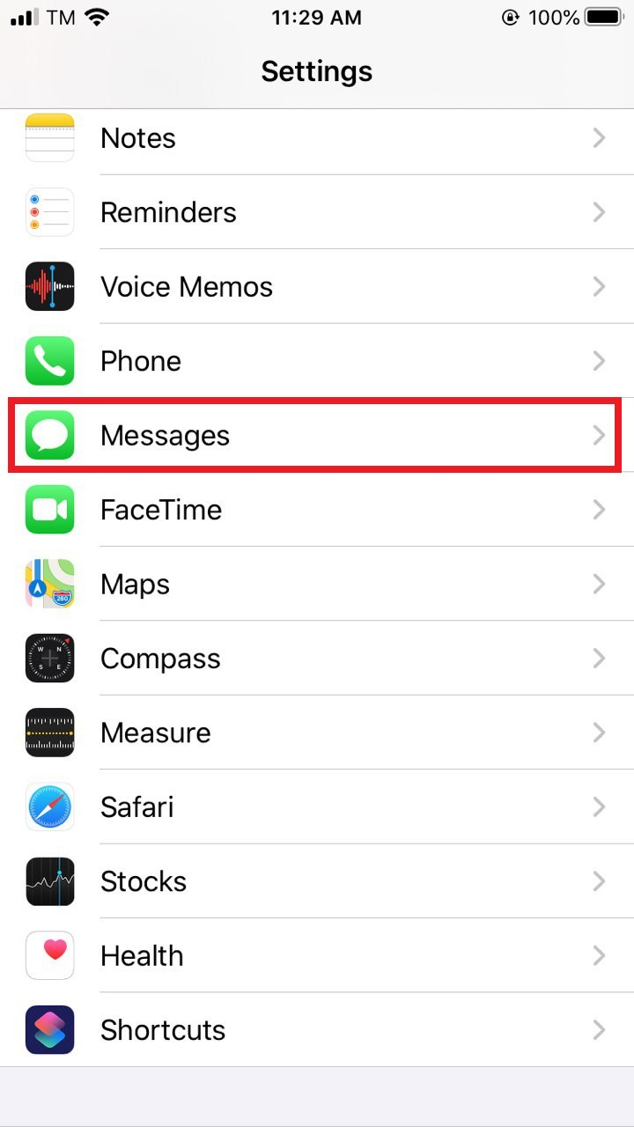
3. Toggle iMessage OFF
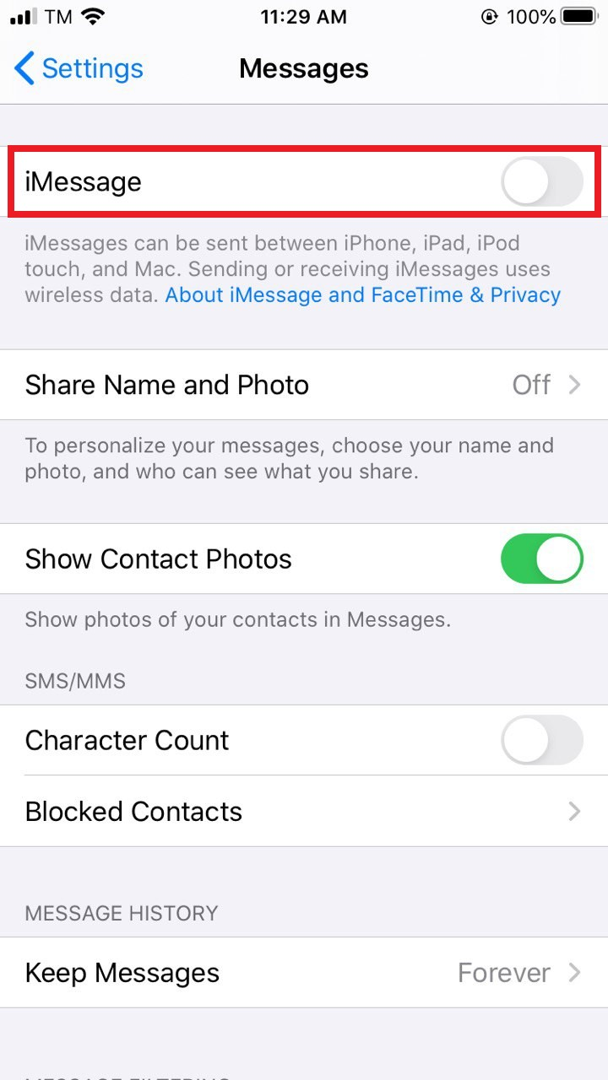
4. Toggle iMessage back to ON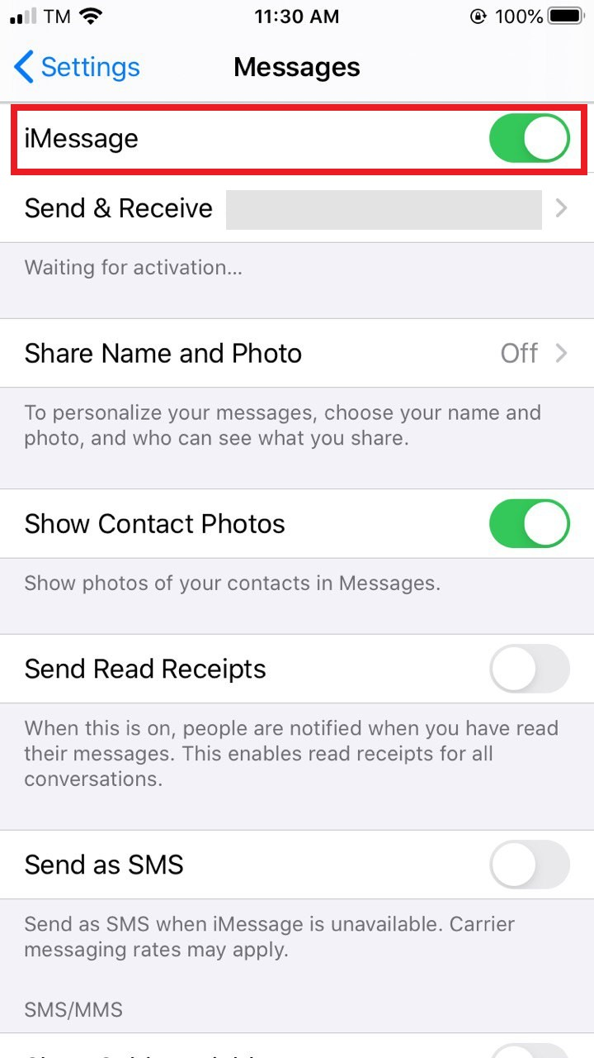
5. Select Enter Messages Manually. 6. Tap on Send & Receive
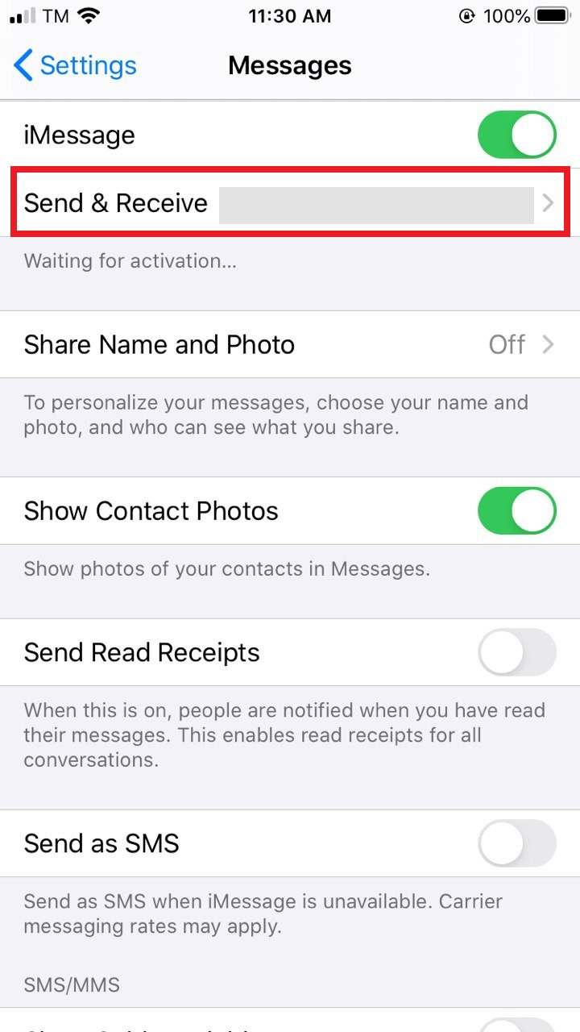
7. Uncheck your phone number and make sure your email address is selected. This will allow you to send and receive iMessages using only your data connection.
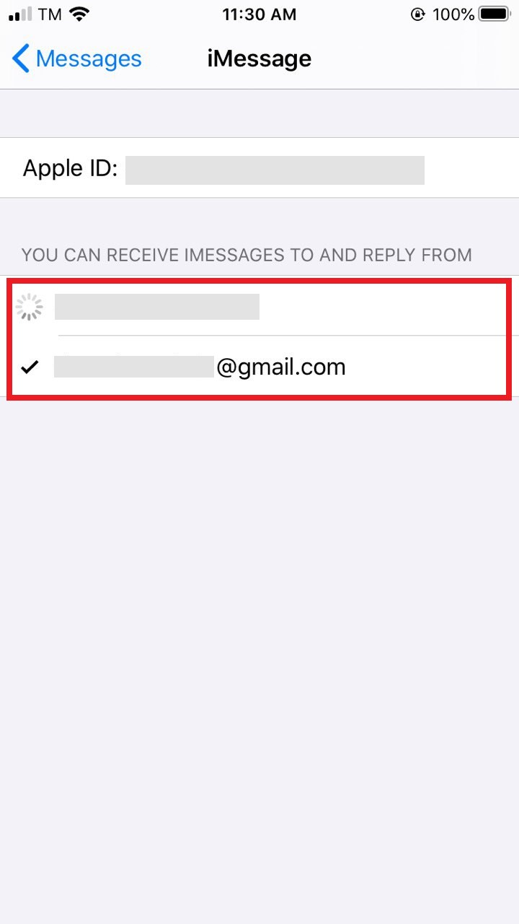
When you no longer need your eSIM and want to switch back to your primary SIM, you can follow these steps: Settings > Messages > Send & Receive, and then check your phone number again.

